-- Create the Student scoring table
CREATE TABLE Studentscoring (
student_id INT PRIMARY KEY,
student VARCHAR(100),
score INT,
country VARCHAR(100),
age INT
);

-- Insert sample data into the Studentscoring table
INSERT INTO Studentscoring (student_id, student, score, country, age) VALUES
(1, 'Alice Johnson', 90, 'USA', 21),
(2, 'Bob Smith', 82, 'Canada', 22),
(3, 'Charlie Brown', 75, 'UK', 23),
(4, 'David Wilson', 88, 'Australia', 20),
(5, 'Eve Davis', 95, 'USA', 19);

-- Select all records from the Studentscoring table to verify
SELECT * FROM Studentscoring;

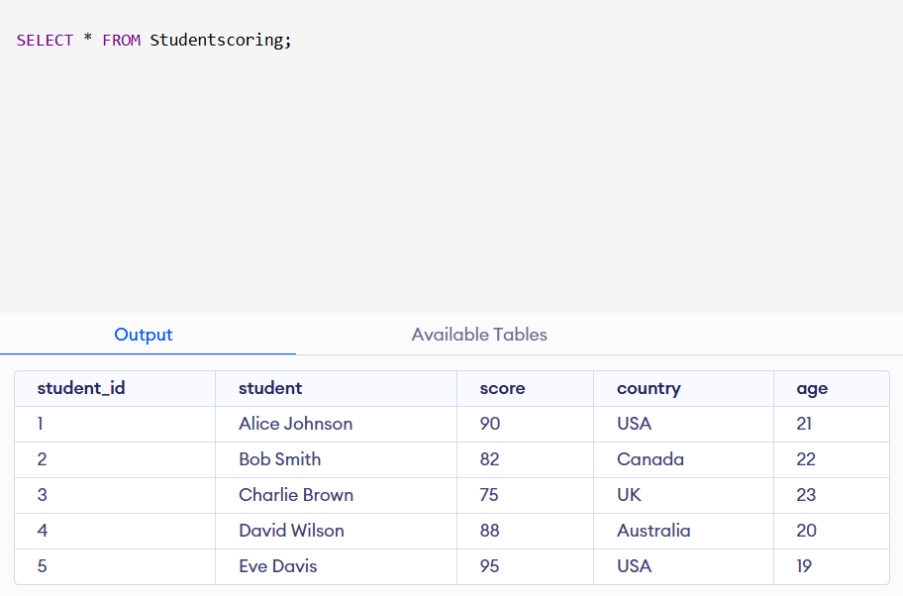

SELECT * FROM Studentscoring WHERE Score > 85 LIMIT 3;

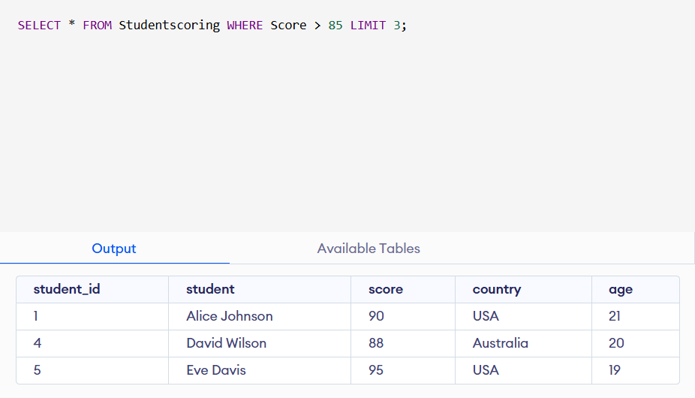

SELECT Country, AVG(Score) AS AverageScore FROM Studentscoring GROUP BY Country;
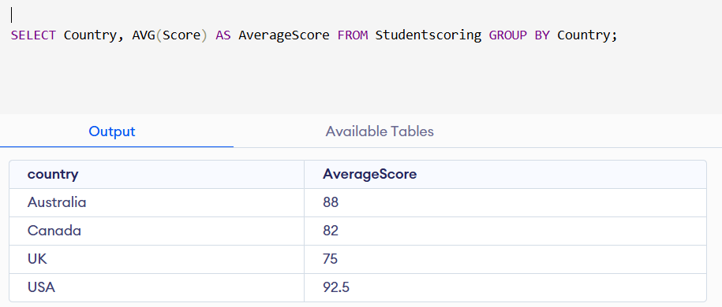

SELECT Student, Country ,Age FROM Studentscoring WHERE Age < 23 ORDER BY Country;

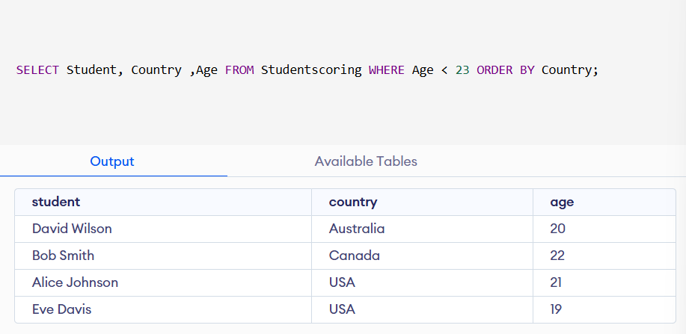

SELECT Country, COUNT(*) AS TotalStudents FROM Studentscoring WHERE Country = 'UK' GROUP BY Country ;


SELECT Student, Score FROM Studentscoring ORDER BY Score DESC LIMIT 3;
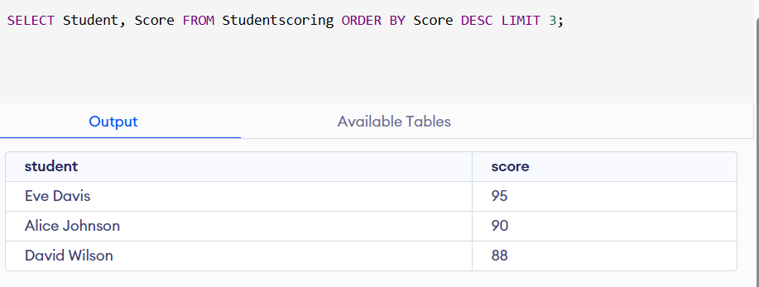
SELECT Country, COUNT(*) AS NumberOfStudents FROM Studentscoring GROUP BY Country HAVING COUNT(*) > 1;

UPDATE Studentscoring SET Score = Score + 5 WHERE Country = 'USA' AND Age BETWEEN 19 AND 21;

SELECT COUNT(*) AS PendingCount FROM Shippings WHERE status = 'Pending';


SELECT customer, COUNT(*) AS TotalDeliveries FROM Shippings WHERE status = 'Delivered' GROUP BY customer;
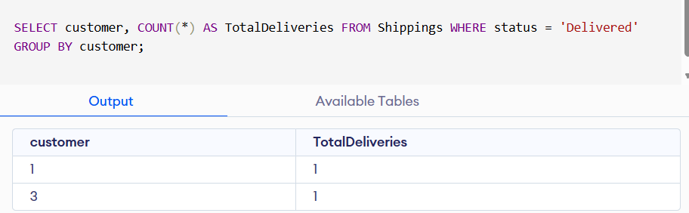
SELECT DISTINCT customer FROM Shippings WHERE status = 'Pending';
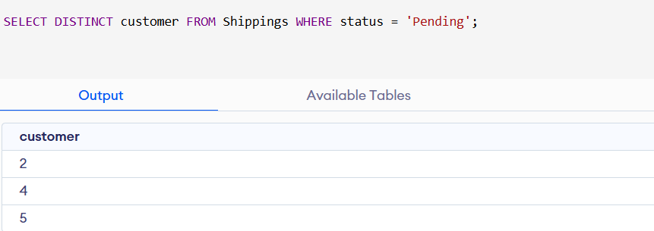

SELECT customer, COUNT(*) AS PendingCount FROM Shippings WHERE status = 'Pending' GROUP BY customer;
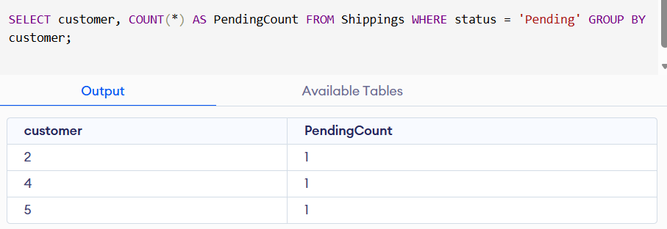
SELECT shipping_id, customer FROM Shippings ORDER BY shipping_id DESC LIMIT 5;
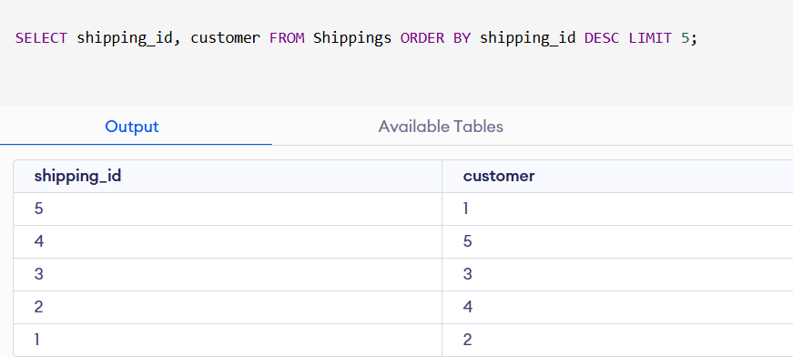
SELECT customer, COUNT(*) AS TotalShippings FROM Shippings GROUP BY customer;
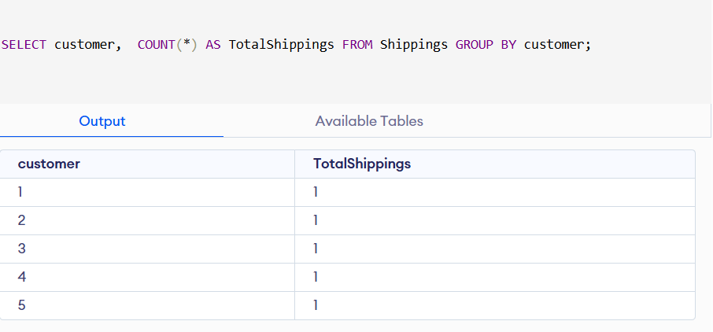
SELECT s.shipping_id, s.customer, c.first_name, c.last_name FROM Shippings s JOIN Customers c ON s.customer = c.customer_id WHERE s.customer IN (1,2);
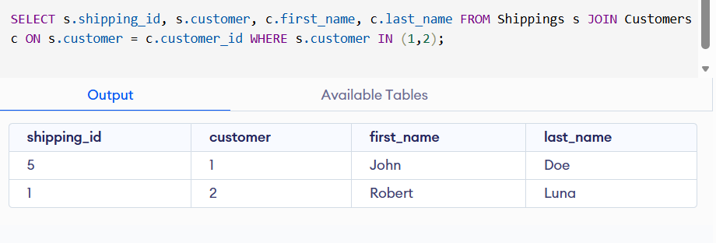

UPDATE Shippings SET status = 'Delivered' WHERE status = 'Pending';
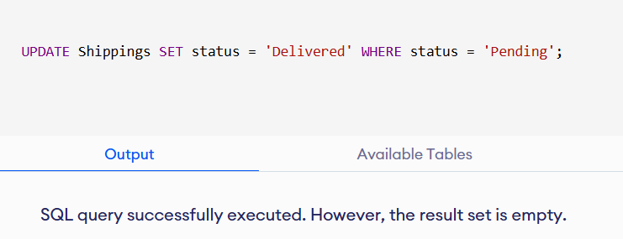
INSERT INTO Shippings (status, customer) SELECT status, customer FROM Shippings WHERE status = 'Delivered';
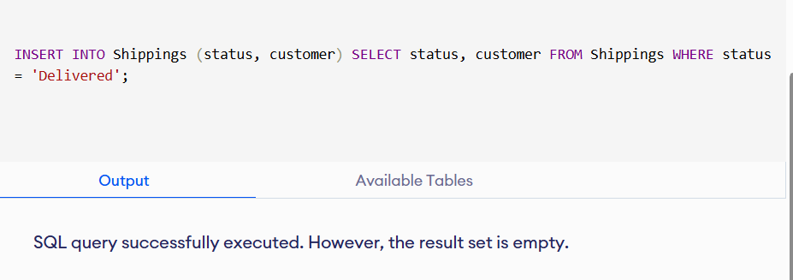
DELETE FROM Shippings WHERE shipping_id > 5;


SELECT * FROM Customers WHERE age > 25 ORDER BY last_name;
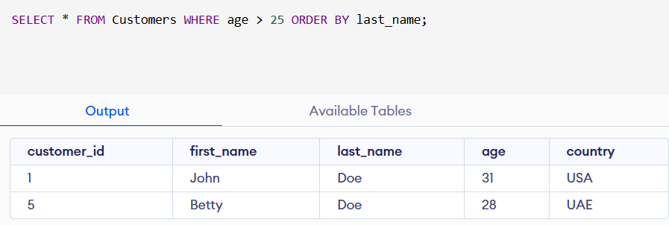
SELECT country, COUNT(*) AS TotalCustomers FROM Customers GROUP BY country;
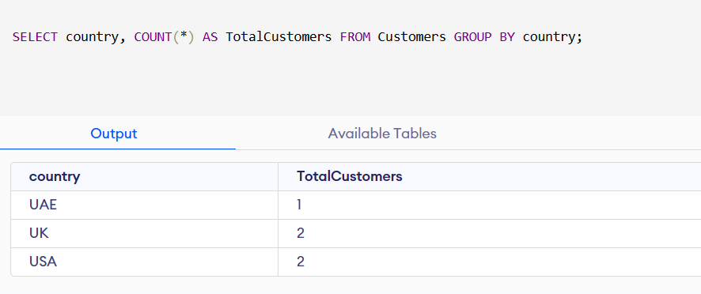
SELECT country, COUNT(*) AS TotalCustomers FROM Customers GROUP BY country;
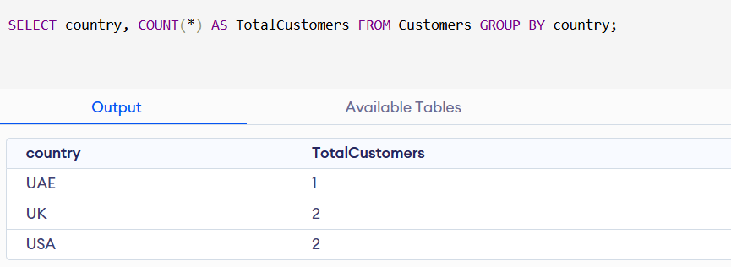

SELECT first_name, last_name FROM Customers WHERE country = 'UAE' ORDER BY last_name;
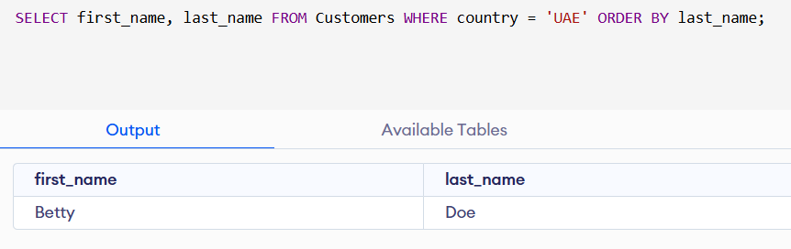
SELECT country, AVG(age) AS AverageAge FROM Customers GROUP BY country;
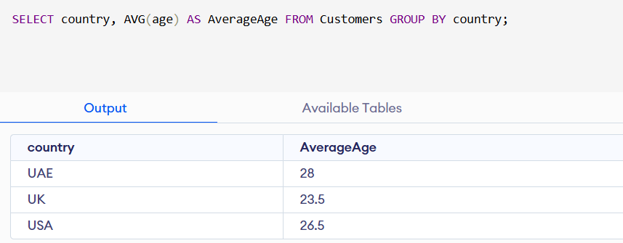

SELECT customer_id, first_name, last_name FROM Customers WHERE first_name LIKE 'J%' OR last_name LIKE 'D%';
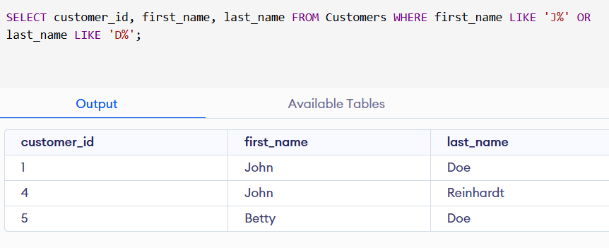
SELECT customer_id, COUNT(*) AS OrderCount FROM Orders GROUP BY customer_id HAVING COUNT(*) > 1;
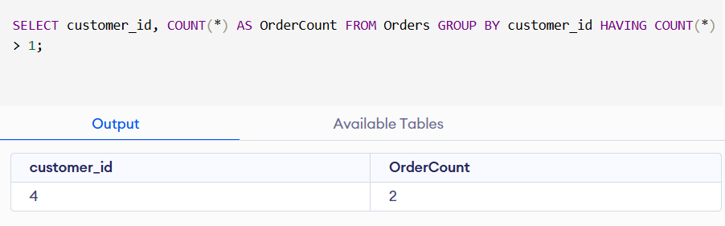
UPDATE Customers SET country = 'Canada'WHERE country = 'UK' AND age >= 25;
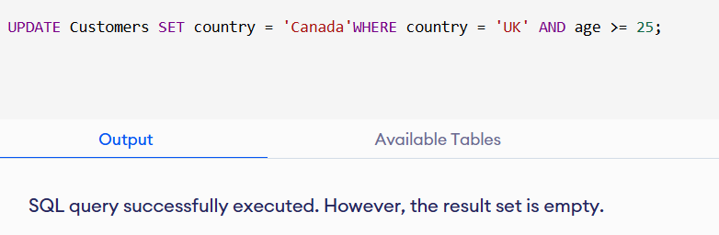

UPDATE Customers SET country = 'UK' WHERE first_name = 'John' AND
last_name = 'Reinhardt' AND age = 25;
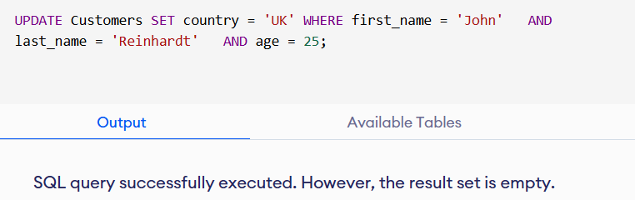

INSERT INTO Customers SELECT * FROM Customers WHERE age < 18;

